Assignment #2

PLEASE NOTE: If the images are too small, I have included them separately in my files. They are in the Documentation folder and labeled by Question numbers.

- Complete the Item class (and the Sales class if you don’t use Java). The instance variables of Item should at least include title, original unit price, and quantity (4 points). Also write a xUnit test class for each of the methods getDiscount, getSubTotal, getDiscountedSubTotal so that the Sale class is fully tested (3 points). Provide a description about how you created the Item class and ensured that it is fully tested (2 points). Attach a screenshot of your test execution (1 point).

The Item class was created initially using a parameterized constructor to set the instance variables titled: org_unit_price -which represents the original unit price, qty -which represents the item quantity, and title -which represents the item title.
Getters are used to retrieve the specific of the instance variables. getTitle() will return the set instance variable title. getOrgUnitPrice() will return the set instance variable org_unit_price. getQty() will return the set instance variable qty. Additionally, I’ve added the getItemTotal() getter which will return the total of the items listed. It will multiply the values of the qty againt the value of the org_unit_price.
I have added the function isTitleValid()that takes the title as an argument . It will return a Boolean function stating true if the title contains only special characters and letters but no numbers, It will return false if there is no title or if numbers are encountered.
I have tested each portion of the Item class in addition to the specified functions from the Sale class written so far in the test.unittest.Item and test.unittest.Sale folders as shown below:

ITEM CLASS
GetTitle testing
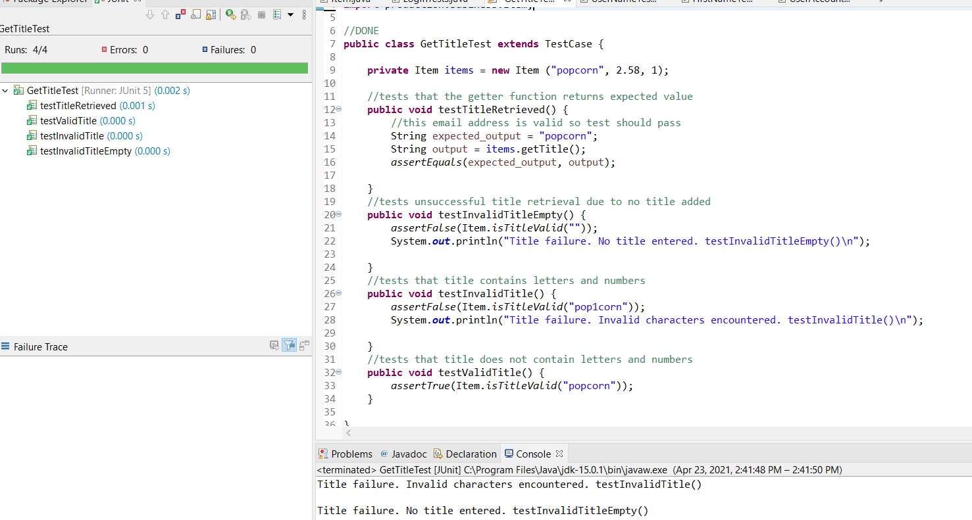
GetOrgUnitPrice testing
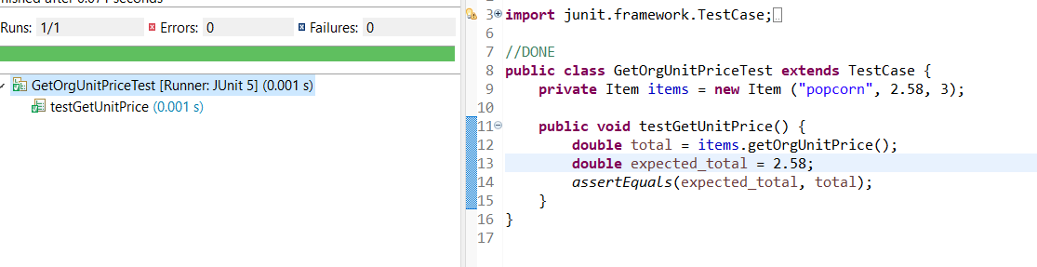

GetQty testing
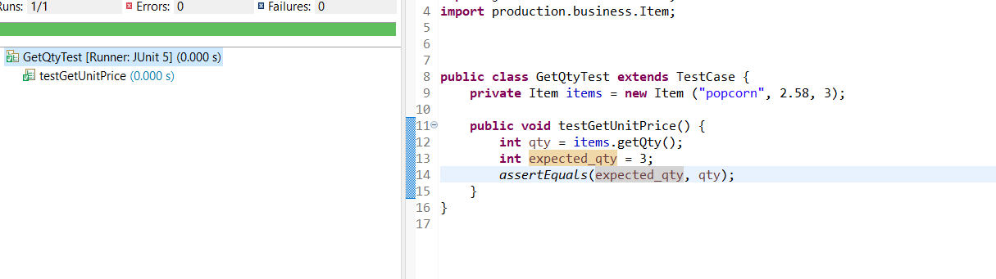

GetItemTotal testing
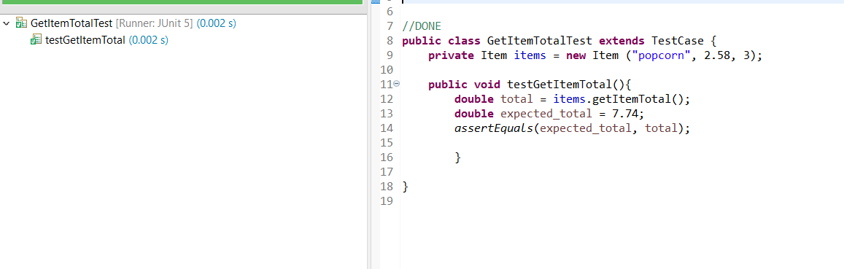

SALES CLASS
Getdiscount testing
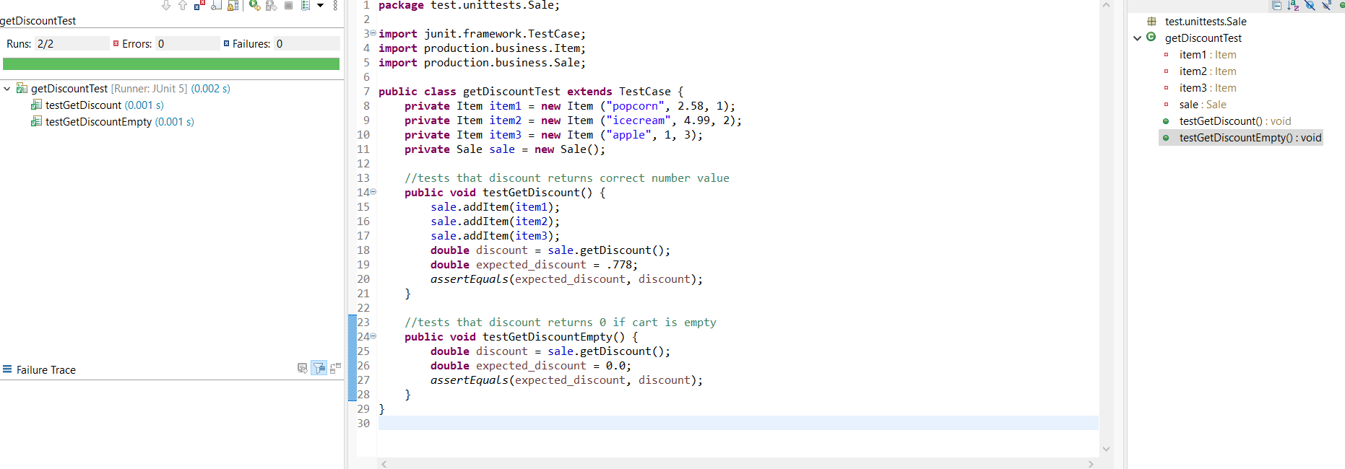

Getsubtotal testing
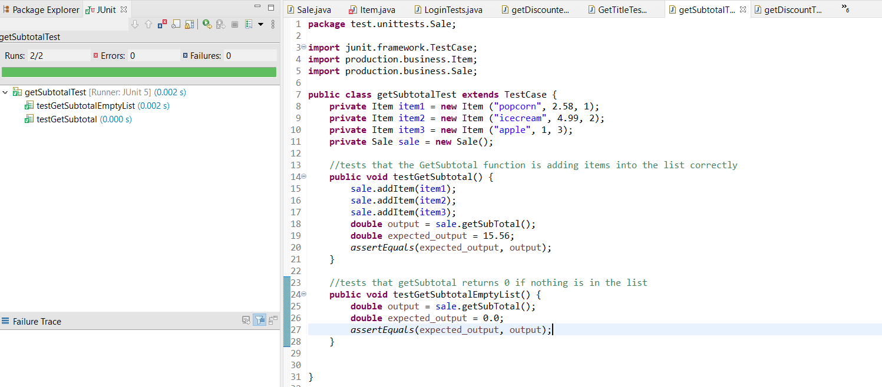
Getdiscountedsubtotaltesting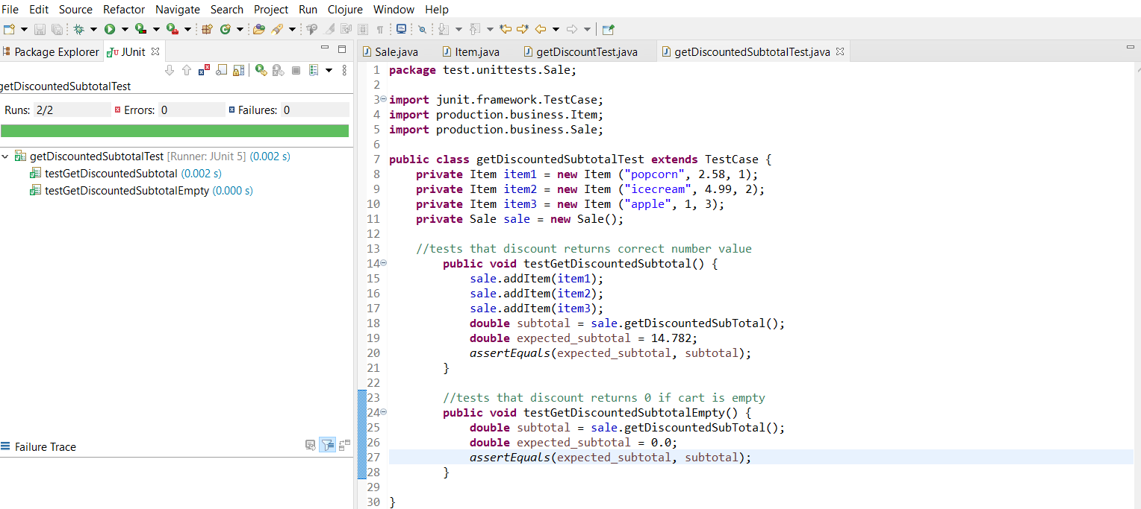
- Update the Sale class to support different discount rates for seniors (e.g., 10%) and preferred customers (15%), in addition to the discount rate in (1) for any customer (12 points). Update your test code with appropriate new tests (4 points). Your program must use switch statement(s), otherwise you will not receive any credit for the problems (3)-(5).
Provide a description about how the code was updated to meet the new requirements and what new tests were created (3 points). Attach a screenshot of your test execution (1 point).

No changes have been made to the Item class for this section. All changes have occurred in the new Sales class titled Sale2.java.
A function titled getDiscountRate() has been changed to contain a switch case. The switch case uses numeric values in which a value of 1 will indicate that it is for seniors and the 10% will be added to the standard 5% all customers get. An integer value of 2 will indicate that it is for preferred customers and 15% will be added to the standard 5% all customers get. Any other value entered will be ignored after displaying an error message and the standard discount will be kept.
A method of determining the discount type has been added via a Sales constructor which will take the integer value discount_num to set the instance variable discount_type.
GetDiscountTest2 () and GetDiscountedSubtotalTest2() are the newly implemented tests created.
GetDiscountTest2() will test the senior discount, preferred customer discount, and standard discount are being applied correctly. It will also check that no discount is applied to an empty cart, and if the incorrect discount type is selected, only the standard discount is applied.
GetDiscountedSubtotalTest2() will test the senior, preferred customer, and standard discount subtotals are correct. It will also check that no subtotal appears if the cart is empty and will apply the standard discount for the subtotal if the incorrect discount type is selected.
I have tested each portion of the new cases written so far in the test.unittest.Sales2 folder as shown below.

GetDiscountTest2
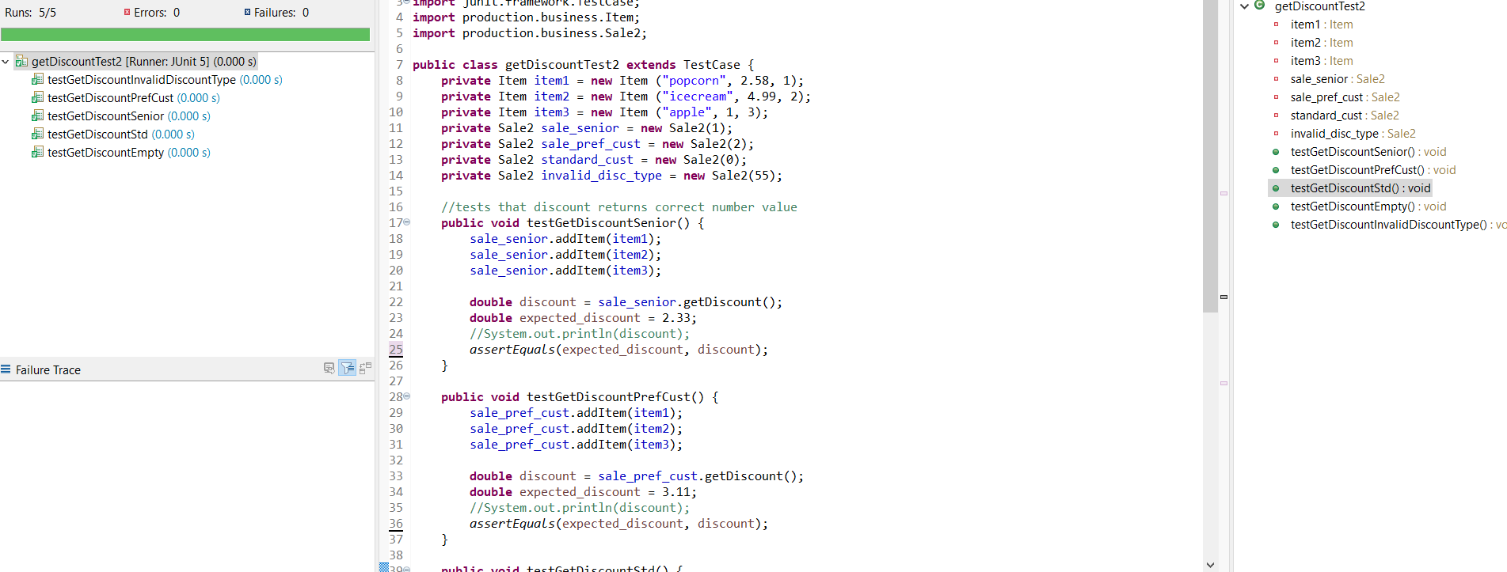

GetDiscountedSubtotalTest2()
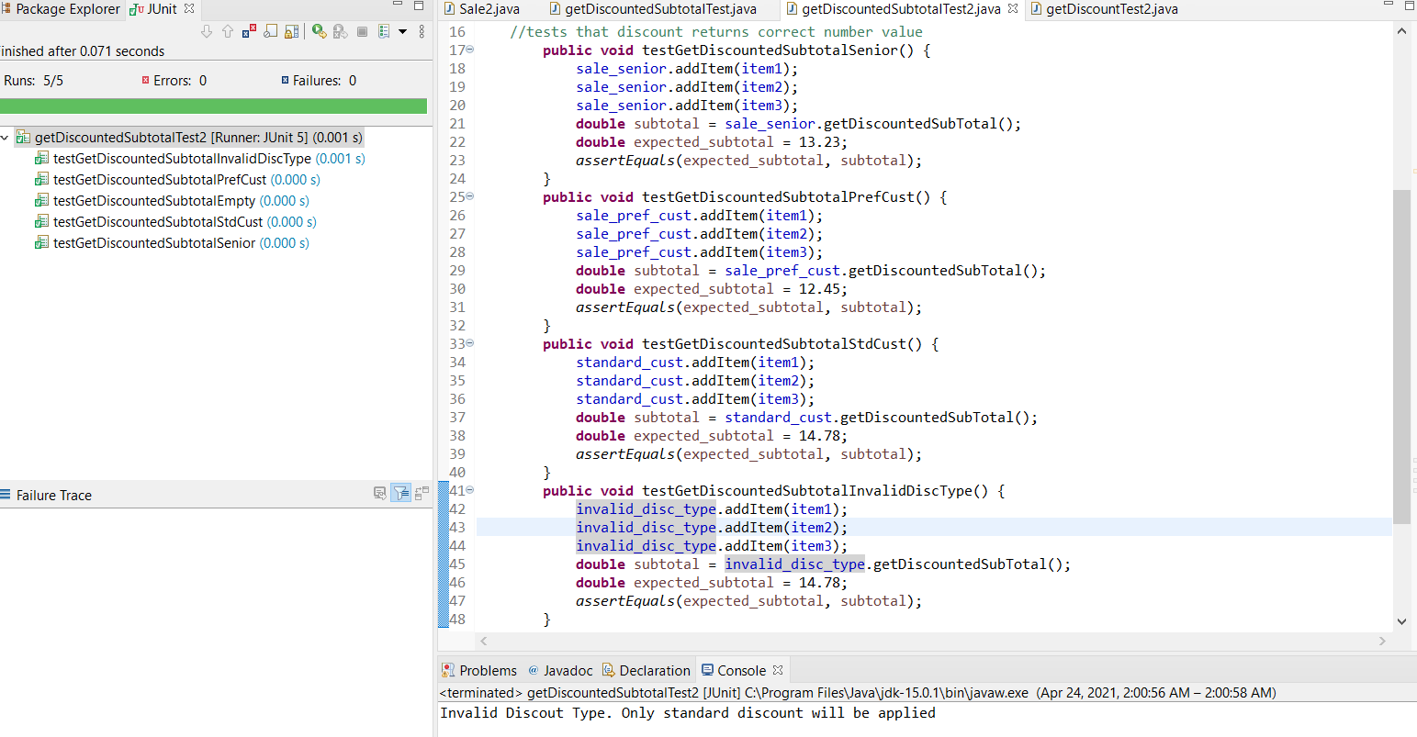

- Update your code for (2) to support that the senior’s discount is only on Tuesday (12 points). Update your test code with appropriate new tests (4 points). Your program must keep the switch statement(s), otherwise you will not receive any credit for the problems (4)-(5).
Provide a description about how the code was updated to meet the new requirements and what new tests were created (3 points). Attach a screenshot of your test execution (1 point).

No changes have been made to the Item class for this section. All changes have occurred in the new Sales class titled Sale3.java.
A method of determining the day has been added via a Sales constructor which will take the integer value day_num to set the instance variable day. 1 is Monday, 2 is Tuesday, 3 is Wednesday, etc. I have left it this way because it allows other discounts to be added on specific days if desired.
A function titled seniorDiscCheck() has been added and will return true if the day is 2 and if it is a senior who is requesting the discount; otherwise, it will return false. getDiscountRate() has been changed slightly to include an if statement. The if statement will check if seniorDiscCheck() returns true; if so, then the senior discount is applied, otherwise the standard discount is used.
seniorDiscCheck() is the newly implemented test file created. This will test if the senior discount should be applied because it is Tuesday, if the discount should be applied despite the member not being a senior, that the correct discount value is being assigned to seniors, and if the conditions are not met, other discounts are applied.
I have tested each portion of the new cases written so far in the test.unittests.Sales3 folder as shown below.

seniorDiscCheck()
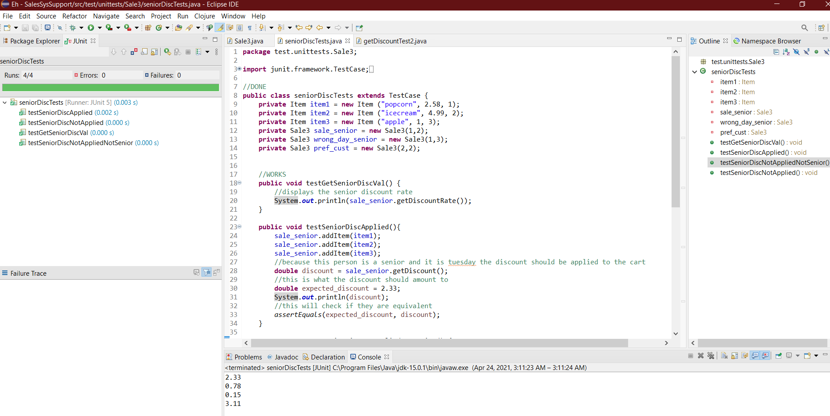

- Refactor your code for (3) to eliminate the switch statement(s) by using class hierarchy and polymorphism (25 points). You will receive no credit if any switch statement is simply changed to if-then-else statements.
Provide a description about how you designed the class hierarchy to replace the switch statement without change of the functionality (4 points). Attach a screenshot of your test execution (1 point).

No changes have been made to the Item class for this section. All changes have occurred in the new Sales class titled Sale4.java and the addition of the PrefCust.java and Senior.java files.
In the Sale4.java file, the constructor has been removed to be replaced with the setDay() setter. This is used to determine if the senior discount should be applied. Additionally, getDiscountRate() has been changed to be an abstract function that will be used in the other classes.
In the PrefCust.java file, the getDiscountRate() function is defined as adding 15% to the 5% discount everyone receives. The result is rounded to two decimal places.
In the Senior.java file, the getDiscountRate() function is defined as adding 10% to the 5% discount everyone receives. The result is rounded to two decimal places.
polymorphTest() is the newly implemented test file created. This will test the same things as in question 4, with the focus being to ensure getDiscountRate() functions as desired after the removal of the switch statements.
I have tested each portion of the new cases written so far in the test.unittests.Sales4 folder as shown below.
polymorphTest()
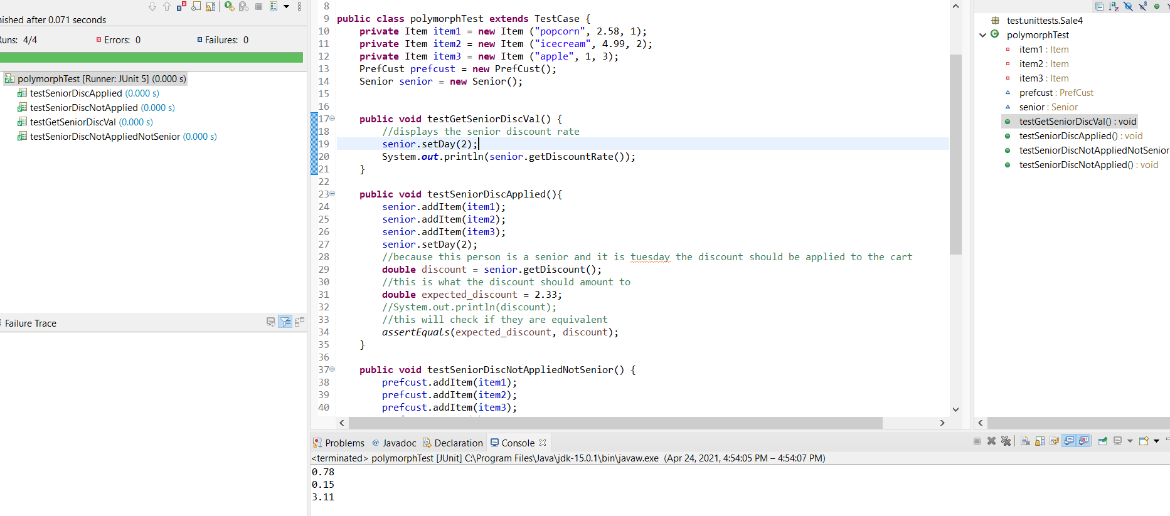

- Update your code for (4) to handle the new discount policy “buy one, get the second (and the rest of the same item) 50% off” for certain items (not all items) (12 points), and add new tests for this new functionality. Make sure your code does not smell. (4 points).
Provide a description about how the code was updated to meet the new requirements and what new tests were created (3 points). Attach a screenshot of your test execution (1 point).

No changes have been made to the PrefCust and Senior class for this section. The Item class and the Sale5 class have both experienced some new changes.
In the Sale5.java file, a new function titled bogo() has been added. There, the function will check if the specified item is authorized to use the bogo discount. If so, the function will take the remaining item quantity and half of their price to determine the new cost of those items. It will then subtract that from the original subtotal to find the new discounted values.
In the Items.java file, the Items constructor has been changed to allow the addition of a discountCheck which will be set to the receive_discount_flag. This new instance variable is a Boolean and is used to determine if a specific item has a discount tied to it. A new function halfOffPrice() has been added which simply cuts the item price in half. The function getDiscountCheck() has been added and will return true if the instance variable is true and there are at least 2 of the same items in the cart. Otherwise, it will return false.
bogoTest () is the newly implemented test file created. This will test that items with the discount flag will receive the bogo discount if there are more than one of them in the cart, it will make sure that the discount is not applied if there are not enough items, it will check that the discount is not applied if the discount flag is not checked, and it will ensure that only the items that the flag is marked for will receive the bogo discount. The discount is not applied to the entire cart.
I have tested each portion of the new cases written so far in the test.unittests.Sales5 folder as shown below.
bogoTest()
